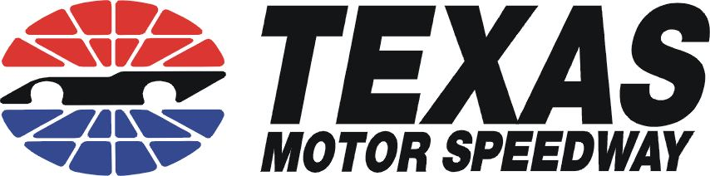

Fast Laps Technical Inspection Form
All cars that will be taking part in a Fast Laps driving group must be inspected prior to their arrival at the track. Our staff will give your car a safety check at the track. If your car cannot pass Tech, we cannot allow it on track! All cars must pass the Safety Check! For your safety and the safety of those sharing the track with you, we recommend that a qualified service person look over your car. While this event is not a race, you could place demands on your vehicle while on-track, which may be in excess of those placed on it when driving around town.

Vehicle Information

Manufacturer: Model: Year: Color:

Owner/Driver: Car Number (if applicable):

Technical Section

Drivetrain: Suspension & Steering:
Engine supports: no cracks or looseness Wheel bearings tightened to specification
Accessory belts snug, no frays or cracks Minimal play in steering linkage
Throttle linkage cables and cranks: smooth action All bushings and pivot points-no deterioration
Throttle return springs: positive Shock absorbers-no leaks
All hoses clean, smooth, and firm Wheels-no bends cracks or retreads
No oil and coolant leaks Lug nuts-tightened to recommended torque
Coolant recovery system-at proper level Tires-proper size for wheel, speed rating
Battery secured with hardware, no cords or string
All wiring properly harnessed
Clutch-smooth engagement, no slippage Personal Safety:
Transmission-no leaks, positive shift action Lap and shoulder belt in good condition OR:
Drive axle(s)-no leaks or excessive play 5-6 point harness for driver and passenger
CV joints-boots in place, no leakage, no noise Fire extinguisher, optional, metal to metal mount
Exhaust system-solid, no leaks, muffled Roll bar-4-point minimum, required on open cars
Braking system: Miscellaneous:
Fluid-clear, reservoir full Windshield-no large cracks
Pedal-firm Windshield wipers-operable, good rubber
Lights-all working, including dashboard indicator Mirrors-left hand and interior required, secure
Master cylinder and lines-no seepage/corrosion Interior-carpet secure, esp. under drivers feet
Calipers-dry Pedals-pads secure
Rotors-no cracks, discoloration or unusual wear Special conditions: please describe:
Pads-adequate to complete the event
Date of last brake fluid change:
By signing this form, I certify that the above inspections have been performed, and any deficiencies have been corrected. I understand that I and I alone am liable for the condition and suitability of this vehicle for use during this event. I release the inspector, Track Days, Staff, Panoz Racing School, LLC and Panoz Texas, LLC from any liability arising from a failure of this vehicle for any reason, including the failure of items listed on this inspection form. Driver/Owner: Date: / /

Panoz Golf Polo: small, medium, large, X-large, XX-large
Black, white, cream and gray – Logo same color as polo ……..$35.00

Panoz Golf Polo: small, medium, large, x-large, xx-large
Black or navy blue – Color logo …………………………………$35.00

Panoz Denim Button Down: small, meduim, large, x-large …………$47.70
Also available in womens style

Panoz Caps: One size fits all – Black only ……………………………..$20.00

Panoz Leather jacket: small, meduim, large, x-large…………………$225.00
Black leather only

Panoz Pullover Jackets (Quivera): Small, meduim, large,x-large….$89.00
Colors: Hunter green or Yellow

