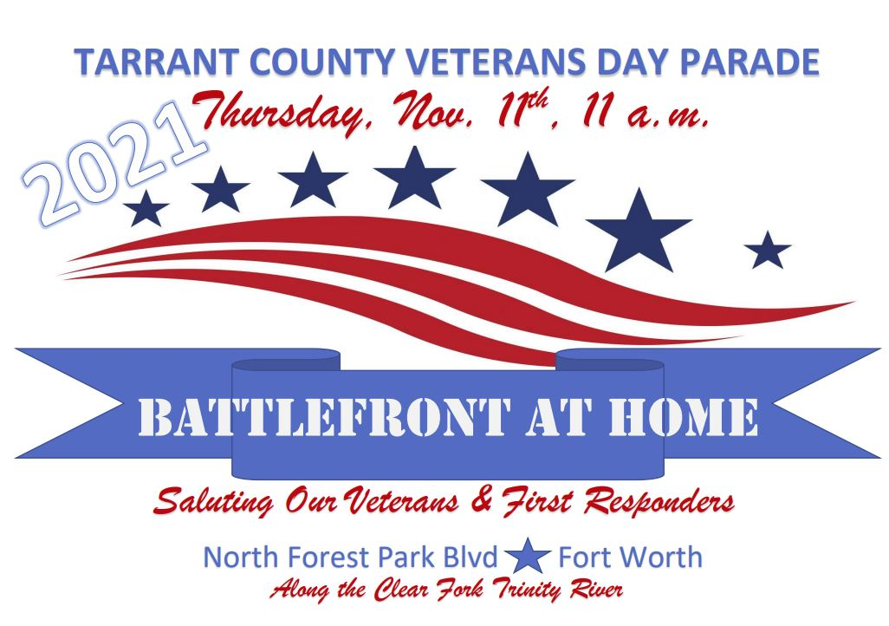
Participants will form up in the Fort Worth Panther Island Pavilion parking lot, march down North Forest Park Blvd. along the Clear Fork of the Trinity River and return. Visit the parade website’s “Parade Day” page at PARADE DAY | 2021 Vets Day Parade (fw2021vetsdayparade.org) for the latest details.

CTV Members
Nov 11. Rain or shine or freezing We need be there 8:30 to line up streets closed 10:15 AM

Military fly over 11AM

Carol Savage will be there earlier and has made small donation.

CTV has signed up 20 Corvettes.

