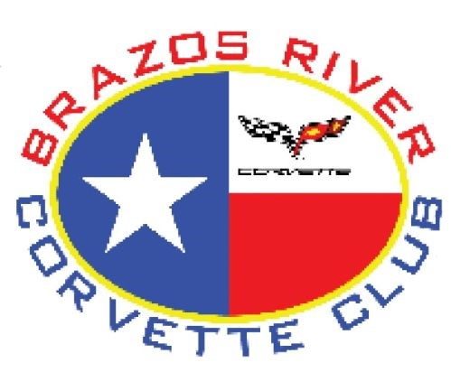
Brazos River Corvette Club
“17th Annual Corvette Show.”

SAVE THE DATE

The Brazos River Corvette Club (BRCC) is having their 17th Annual Corvette Show, to be held on Saturday, October 14, 2023 located on Granbury's historic square. Our car show is exclusively for Corvettes from C1 through C8.
This year’s proceeds from the car show will go to the BRCC's primary charity, Hood County Volunteer Fire Department, Tolar.
Gate opens at 7:30 am. Judging starts at 10:30 AM.
We will have 2 Best of Show winners this year: C1 through C4, and C5 through C8. Over 50 trophies will be awarded along with a bottle of wine.
More information will follow. Hope to see you at the show making this the best BRCC Corvettes “On the Historic Square” Car Show.

Contact person:
Theresa Halford
432–634-7214
Email: thalford@pathtechltd.com

